Sports Concussion Assessment System Project

Phase I Part 1
Include your actor and major use case descriptions on this page. You may add pages if necessary.

Actors
Athlete:
- Primary actor who will submit his or her symptoms (health conditions or concerns) through the application and get feedback on their health from the medical practitioner based on the symptom scores.

Medical practitioner:
- Secondary actor who will interact with the primary actor (athlete) to assess the symptoms that was submitted and advise each athlete as needed.

Major Use Cases
- Login: Athlete and Medical practitioner can log into the system to access each’s own functionalities.
- Enter symptoms: Athletes will enter their health conditions or concerns based on well-defined symptoms and pain levels on a numerical scale from 0 (no pain) to 6 (severe pain). Data/symptoms for the 5 most recent game symptoms will be stored.
- View risk indicators: Athletes can view the risk indicators for their health status based on the reported symptoms.
- View the advice from the medical practitioners: Advice from the medical practitioner can be seen by the athlete.
- View the symptom summary: Athletes can see the summary of symptoms of the 5 most recent games.
- View entered athlete symptoms: Medical practitioners can view and assess the symptoms submitted by the athletes.
- Give advice to athletes: Medical practitioners can give needed feedback to the athletes individually and accordingly.

Phase I Part 2
Use Astah to draw a use case diagram. Use proper UML notation. Take a clear screenshot of your completed diagram and paste it on this page.

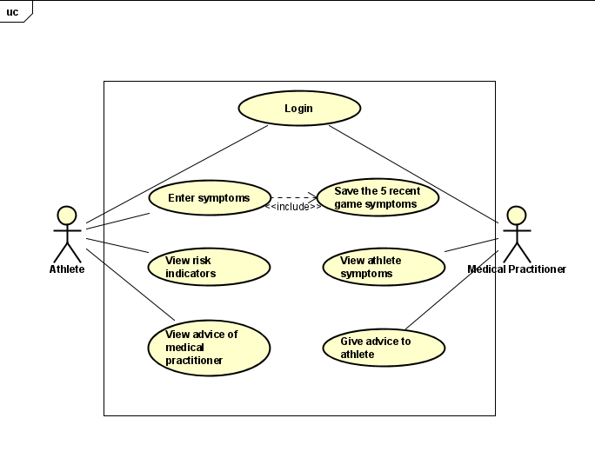

Phase II Part 1
Include your use case descriptions on this page. You may add pages if necessary.

Use Case Description for Athlete:
Preconditions: Athlete must have logged into the application and can access the symptom evaluation.

Postconditions: Athletes can submit their symptoms to the system and view symptom summary.

Flow:
- Login: Athletes can register themselves and log into the system to access their functionalities.
- Enter symptoms: Athletes will enter their health conditions or concerns based on well-defined symptoms (the evaluation form with 22 symptoms) and pain levels on a numerical scale from 0 (no pain) to 6 (severe pain) to be submitted. The data/symptoms for the 5 most recent game symptoms are stored.
- View risk indicators: Athletes can view the risk indicators for their health status based on the reported symptoms.
- View the advice from the medical practitioners: Advice from the medical practitioner can be seen by the athlete.
- View the symptom summary: Athletes can see the summary of symptoms of the 5 most recent games.

Use Case Description for Sport Medical Practitioner
Preconditions: Medical practitioner must have logged into the application.

Postconditions: Medical practitioner can review the athletes’ symptoms and make further notes as well as provide feedback given the athletes’ conditions.

Flow:
- Login: Medical practitioners can log into the system to access their functionalities.
- View entered athlete symptoms: Medical practitioners can view and assess the symptoms submitted by the athletes. They can see who has submitted symptom evaluations and the system shows the data, allows for up to the past 5 games.
- Give advice to athletes: Medical practitioners can give needed feedback to the athletes individually and accordingly.

Phase II Part 2
List the potential objects in the provided space. Use the template provided to create a CRC diagram for each object. You may add pages if necessary.

Potential Object
- Athlete

Class: Athlete
Responsibilities  - Input the symptom pain levels  - View symptom summaries  - View feedback from medical practitioner | Collaborators  - Medical Practitioner  - Sports Concussion Assessment System  - Symptom History

- Medical Practitioner

Class: Medical Practitioner
Responsibilities  - Review and assess submitted athlete symptom data  - Provide athletes with feedback | Collaborators  - Athlete  - Sports Concussion Assessment System  - Symptom History

- Sports Concussion Assessment System

Class: Sports Concussion Assessment System
Responsibilities  - Manage athletes’ symptom entries and feedback data  - Refreshes the data/updates information | Collaborators  - Athlete  - Medical Practitioner  - Symptom History

- Symptom History

Class: Symptom History
Responsibilities  - Store what symptoms athletes have and their ratings  - Store and display feedback on symptoms entries  - Allow medical practitioner to access the data for evaluation | Collaborators  - Athlete  - Medical Practitioner

Phase II Part 3
Use Astah to draw the class diagram. Use proper UML notation. Take a clear screenshot of your completed diagram and paste it on this page.

